**Institute of Engineering & Management**

**Department of Computer Science & Engineering**

**Communication Engineering Laboratory for 2nd year 4th semester 2018**

**Code: CS 491**

**Date:** 18/9/18

**ASSIGNMENT-2**

**Experiment Name: Square waves in three different frequencies**

**Objective:** Generating three Square waves in three different frequencies and displaying it in DSO

**Theory:** A function generator is usually a piece of electronic test equipment or software used to generate different types of electrical waveforms over a wide range of frequencies. Some of the most common waveforms produced by the function generator are the sine, square, triangular and saw-tooth shapes  
A digital storage oscilloscope (often abbreviated DSO) is an oscilloscope which stores and analyses the signal digitally rather than using analog techniques.   
A waveform is the shape and form of a signal such as a wave moving in a physical medium or an abstract representation. Here we are working with three waveforms mainly sine wave, square wave, and triangular wave.  
A square wave is a non-sinusoidal periodic waveform in which the amplitude alternates at a steady frequency between fixed minimum and maximum values, with the same duration at minimum and maximum.  
We are generating these three waveforms using function generator and displaying them in the DSO(Digital Storage Oscilloscope) for different frequencies.

**Observation Table:**

**Square Wave:**

|  |  |
| --- | --- |
| Function Generator | Oscilloscope |

|  |  |  |  |  |
| --- | --- | --- | --- | --- |
| Frequency | Volt(V) | Frequency | Vpp(V) | Vp(V) |
|  |  |  |  |  |
|  |  |  |  |
|  |  |  |  |
|  |  |  |  |  |
|  |  |  |  |
|  |  |  |  |
|  |  |  |  |  |
|  |  |  |  |
|  |  |  |  |

**Waveforms:**

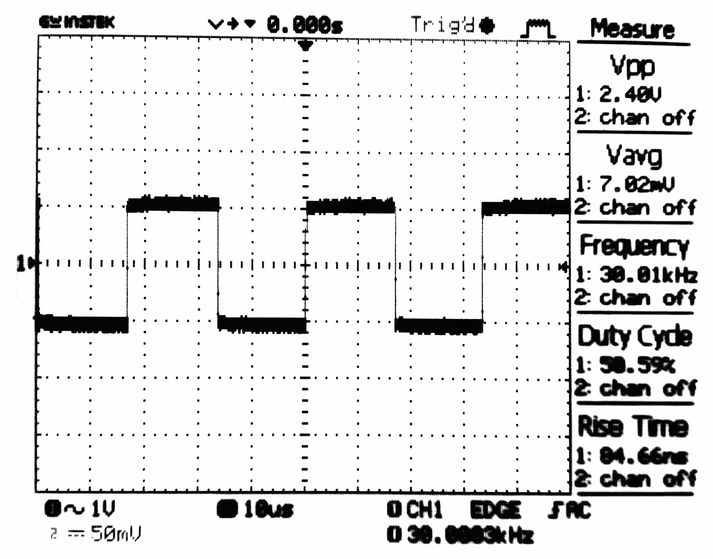

Square wave

**Discussion:** From this experiment we learned how to use a function generator to generate Square waves of different frequencies and amplitudes and also how to display the wave in DSO